**Seminar Report**

On

**DIGITAL TWIN TECHNOLOGY**

By

Giramkar Shrushti Ankush

Roll No: 19

Under the guidance

of

**Prof. Sayyad.J. I**

Year of Submission: 2023-2024



HSBPVT’S

PARIKRAMA FACULTY OF ENGINEERING, KASHTI

DEPARMENT OF COMPUTER ENGINEERING



HSBPVT’S

PARIKRAMA FACULTY OF ENGINEERING, KASHTI

DEPARMENT OF COMPUTER ENGINEERING

**CERTIFICATE**

This is to certify that **Miss.Giramkar Shrushti Ankush** from **Third Year Computer Engineering** has successfully completed her seminar work titled “**Digital Twin Technology”** at Faculty of Engineering, Kashti in the partialfulfillment of the Bachelor’s Degree in Engineering of Savitribai Phule Pune University.

Prof.Sayyad. J.I

Prof.Hiranwale. Sachin

**Guide Name Head Of Department Principal**

**ACKNOWLEDGEMENT**

I would like to express my deepest sense of gratitude to my guide **Prof. J. SAYYAD** who offered her continuous advice and encouragement throughout the course of this project work. I thank her for the systematic guidance and providing all the assistance needed to complete the work. She inspired us greatly to work in this area.

Her willingness to motivate us contributed tremendously to my project. Her guidance and discussions with me are invaluable in realization of this report. I also thankful to all Faculties of other Engineering Department for her continuous encouragement and guidance throughout the entire project work.

**MISS. SHRUSHTI ANKUSH GIRAMKAR.**

**ABSTRACT**

Digital Twin technology is an emerging concept that has become the centre of attention for industry and, in more recent years, academia. The advancements in industry 4.0 concepts have facilitated its growth, particularly in the manufacturing industry. The Digital Twin is defined extensively but is best described as the effortless integration of data between a physical and virtual machine in either direction.

The challenges, applications, and enabling technologies for Artificial Intelligence, Internet of Things (IoT) and Digital Twins are presented. A review of publications relating to Digital Twins is performed, producing a categorical review of recent papers. The review has categorised them by research areas: manufacturing, healthcare and smart cities, discussing a range of papers that reflect these areas and the current state of research. The paper provides an assessment of the enabling technologies, challenges and open research for Digital Twins.

Though the concept originated earlier, the first practical definition of a digital twin originated from NASA in an attempt to improve the physical-model simulation of spacecraft in 2010. Digital twins are the result of continual improvement in the creation of product design and engineering activities. Product drawings and engineering specifications have progressed from handmade drafting to computer-aided drafting/computer-aided design to model-based systems engineering and strict link to signal from the physical counterpart.

**TABLE OF CONTENTS**

|  |  |
| --- | --- |
| **1** | **Introduction** |
| **2** | **History** |
| **3** | **Literature Survey** |
| **4** | **Architecture (Block Diagram)** |
| **5** | **Implementation** |
| **6** | **Example** |
| **7** | **Application** |
| **8** | **Challenges** |
| **9** | **Future Scope** |
| **10** | **Conclusion** |
| **11** | **References** |

**INTRODUCTION**

A digital twin, in simple terms, is a virtual model of a product, process, or service. By pairing the virtual and physical worlds, digital twins enable data analysis, system monitoring to alert problems, downtime prevention, and future planning via simulations.

Digital Twin is at the forefront of the industry 4.0 revolution facilitated through advanced data analytics and the Internet of Things (IoT) connectivity. IoT has increased the volume of data usable from manufacturing, healthcare, and smart city environments.

The IoT’s rich environment, coupled with data analytics, provides an essential resource for predictive maintenance and fault detection to name but two and also the future health of manufacturing processes and smart city development, while also aiding anomaly detection in patient care, fault detection and traffic management in a smart city. The Digital Twin can tackle the challenge of seamless integration between IoT and data analytics through the creation of a connected physical and virtual twin.

A Digital Twin environment allows for rapid analysis and real-time decisions made through accurate analytics. This paper provides a comprehensive review of Digital Twin use, its enabling technologies, challenges and open research for healthcare, manufacturing and smart city environments. Since the centre of gravity of the literature relates to manufacturing application, the review has tried to capture relevant publication from 2015 onwards across three areas: manufacturing, healthcare and smart cities. The paper, uses a range of academic sources found through keywords related to IoT and data analytics, but with an overall aim of identifying papers relating to Digital Twin.

**HISTORY**

Digital twins were anticipated by David Gelernter’s 1991 book Mirror World. The concept and model of the digital twin was first publicly introduced in 2002 by Michal Grieves, at a Society of Manufacturing Engineer conference in Tory, Michigan Grieves proposed the digital twin as the conceptual model underlying product lifecycle management (PLM).

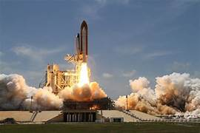

The digital twin concept, which has been known by different names (e.g., *virtual twin)*, was subsequently called the "digital twin" by John Vickers of NASA in a 2010 Roadmap Report. The digital twin concept consists of three distinct parts: the physical object or process and its physical environment, the digital representation of the object or process, and the communication channel between the physical and virtual representations.

The International Council of System Engineers (INCOSE) maintains in its Systems Engineering Book of Knowledge (SEBoK) that: "A digital twin is a related yet distinct concept to digital engineering. The digital twin is a high-fidelity model of the system which can be used to emulate the actual system." The evolving US DODDigitalEngineering Strategy initiative, first formulated in 2018, defines a digital twin as "an integrated multi-physics, multiscale, probabilistic simulation of an as-built system, enabled by a Digital Thread, that uses the best available models, sensor information and input data to mirror and predict activities over the life of its corresponding physical twin”.

**LITERATURE REVIEW**

**Aidan Fuller:**

Aidan Fuller (Student Member, IEEE) received the B.Sc. degree in software engineering and the M.Sc. degree in advanced computer studies Liverpool John Moore’s University, in 2017 and 2018.  He is currently a SEND Graduate Ph.D. Researcher with the School of Computing and Mathematics, Keele University, and is a member of the Software and Systems Engineering Research Group. His research interests include software engineering, AI (machine learning and deep learning), the Internet of Things, the industrial IoT, and digital twins.

**Zhong Fan:**

Zhong Fan (Member, IEEE) received the B.S. and M.S. degrees from Tsinghua University, China, and the Ph.D. degree from Durham University, U.K. He was a Research Fellow of Cambridge University, a Lecturer with Birmingham University, and a Researcher with Marconi Laboratories, Cambridge. He is a Professor and the Academic Director of SEND with Keele University.

Before that, he was a Chief Research Fellow of Toshiba Research Europe, Bristol, U.K., leading research on the IoT, smart grid, data analytics, and 5G communications. He received the BT Short-Term Fellowship for his work at BT Laboratories. His research interests include smart energy, the IoT, and machine learning applications.

**How does digital twin technology works**

The life of a digital twin begins with experts in applied mathematics or data science researching the physics and operational data of a physical object or system in order to develop a mathematical model that simulates the original. The developers who create digital twins ensure that the virtual computer model can receive feedback from sensors that gather data from the real-world version. This lets the digital version mimic and simulate what is happening with the original version in real time, creating opportunities to gather insights into performance and any potential problems.

A digital twin can be as complex or as simple as you require, with differing amounts of data determining how precisely the model simulates the real-world physical version. The twin can be used with a prototype to offer feedback on the product as it is developed or can even act as a prototype in its own right to model what could occur with a physical version when built.

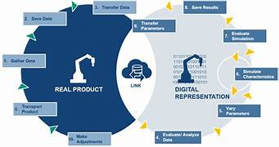

A digital twin is a virtual model designed to accurately reflect a physical object. The object being studied, for example a wind turbine is outfitted with various sensors related to vital areas of functionality. These sensors produce data about different aspects of the physical object’s performance, such as energy output, temperature, weather conditions and more. This data is then relayed to a processing system and applied to the digital copy.

**Digital Twin Technology Evolution Stages**

Gartner’s three-stage digital twin technology evolution model has been widely used, in which the real world is duplicated in the first stage, controlled in the second stage, and is optimized in the third stage. Therefore, in most existing investigations, after duplicating a single product or system in the virtual world, it can be optimized based on the simulation results of the duplicated model.

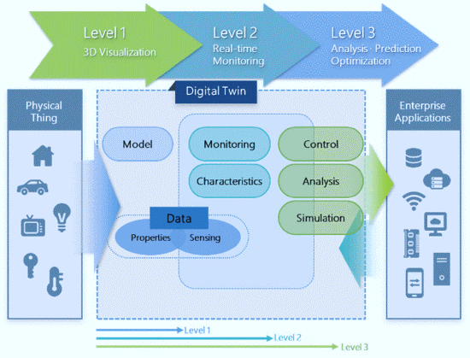

* **Stage 1 – Mirroring:** Duplicating a physical object into a digital twin.
* **Stage 2 – Monitoring**: Monitoring and controlling the physical object based on the analysis of the digital twin.
* **Stage 3 – Model and simulation**: Optimizing the physical object through the simulation results of the digital twin.
* **Stage 4 – Federation**: Configuring federated digital twins, optimizing complex physical objects, and inter-operating federated digital twins and complex physical objects.
* **Stage 5 – Autonomous**: Autonomously recognizing and solving problems in federated digital twins and optimizing physical objects according to the federated digital twin solution.

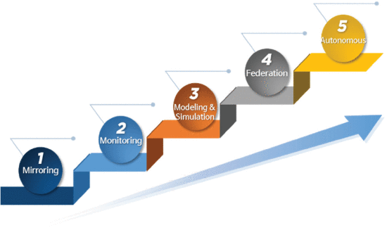

In the first three stages, a single physical object is as a single digital twin and optimized through the simulation result of a single digital twin. In the mirroring stage, a physical object is replicated as a digital object. Further, the main replicated elements should be selected to reduce the burden in the mirroring process. The main replicated elements may vary depending on the main purpose of the digital twin. In a transportation digital twin, traffic volumes and roadmaps can be the main replicated elements. In a smart farm digital twin, the type of vegetable or grain, sunlight, and water can be the main replicated elements.

Therefore, focusing on duplicating the main elements is crucial to reduce the burden in the mirroring process. In addition, consistency between the replicated twin world and the real world must be considered to maintain the validity of the digital twin. Synchronization engines are usually considered for digital twins because digital twins need to manage and synchronize various sensors to ensure consistency. Therefore, in the mirroring stage, the synchronization engine can manage many sensors and maintain consistency between the replicated twin world and the real world.

**ARCHITECTURE**

**BLOCK DIAGRAM OF DIGITAL TWIN TECHNOLOGY:**

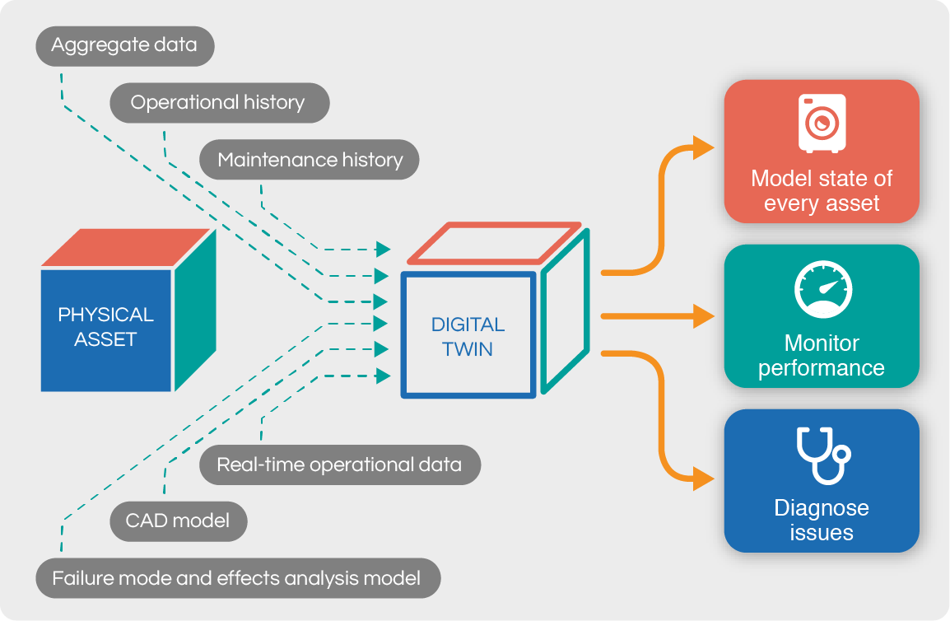

The interaction APIs are realized with appropriate technology available in the tier. Digital twin implementations might be deployed using an app store like those for mobile computing. The app store content is replicated in each Industrial IoT tier and enables direct access for third party participation in the common ecosystem. App store transactions in a disconnected tier are journaled and replicated to other tiers when communication is re-established.

Each digital twin deployment can have a different information model allowing for diversity in data representation and relationships. This parallels the trend in microservices where every service has a unique set of programming interfaces, and applications must know how to use them. In a similar way, the digital twin information model API enables discovery and classification of types, properties and instances.

Our vision is that digital twins can be deployed in any Industrial IoT tier, realized with the available technology choices, and synchronization between digital twins is the only communication between tiers. Data replicated into a digital twin looks like ingest and triggers the associated published notification events. The following expectations summarize the digital twin architectural capabilities and their motivations.

**App store deployment of configuration:** Digital twin information model and policy definitions are deployed independent of services as first class participants for Industrial IoT. This provides a separation of concerns between data and service ownership and enables declarative integration of applications, services and digital twins.

**Integrated information model:** Asset types and instances are crucial aspects of the ecosystem: discoverable, navigable and organized independent of naming conventions. Classification of types apply to related instances and property values. Multiple information models can be federated within a tier to provide a broad view of the available storage.

**Flexible classification of types, properties and instances:** Every digital twin can invent its own type system, imposing the constraint on clients to configure and program accordingly. No different than the complexity introduced by microservice APIs, it is unrealistic that all Industrial IoT applications will agree on a common information model taxonomy and attributes.

**Encrypted data at rest and in transfer:** Digital twins can store encrypted data, only readable with guaranteed integrity by the provisioned users. Encryption is used for sensitive API parameters to protect privacy and reduce the possibility for malicious control.

**Role-based access control configured for authenticated users:** A digital twin imposes a security domain to protect and manage access to data. Digital twin owners define the EULA policies by which sharing is allowed, protecting intellectual property and sensitive information. Synchronized replicas in adjacent tiers are guarded by the same controls.

**IMPLEMENTATION**

To implement digital twin technology efficiently, we propose a digital twin implementation layer model. The proposed implementation layer model refers to the development phase of implementing, operating, and servicing digital twin technologies. Digital twin technology can be implemented step-by-step according to the proposed layer.

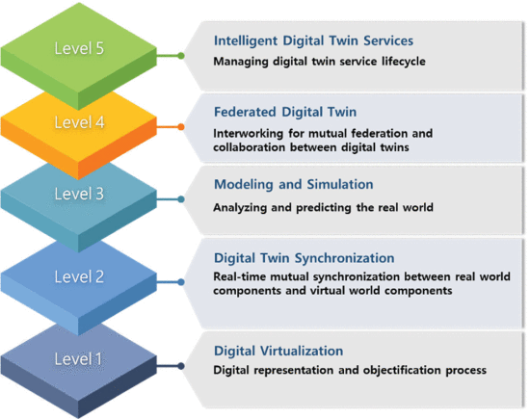

The digital twin implementation layers provide the required functional goals to implement digital twin-based services step-by-step. However, because the digital twin is not a specific technology, but a service platform that integrates various intelligent technologies to implement each layer, various technology elements have to be considered.

For a practical implementation methodology, this study suggests the technology elements for each implementation layer. A technology element refers to technology required to build each implementation layer. The suggested technology elements for the implementation layers. The digital twin developer can implement and improve the digital twin model according to the implementation layers and technology elements.

**Layer 1: Digital Virtualization**

Digital virtualization is the base layer for the digital twin implementation. In this layer, information of various target objects in the real world is collected and transferred to a digitalized virtual world. In addition, digitalized information is processed for the analysis and visualization of target objects. This layer consists of eight technological elements. The technology elements of this implementation layer are virtual sensor, sensor placement optimization, object identification, multidimensional information and object visualization, data collection and processing, digital object distributed storage, processing, and analysis framework, multi-dimensional data causal relation analysis and integration technology, and real-world data preprocessing.

Virtual sensor, sensor placement optimization, and object identification technologies are related to the sensing and detection of target objects. Reference   presented the model and implementation of redundant virtual sensors and validated the implemented model. Reference   showed an integration technique for synthetic sensing within a digital twin framework. Based on the described virtual sensing technique   and synthetic sensing technique, the digital twin can efficiently detect and store high-quality physical object data. For the visualization of virtual objects, multidimensional information and object visualization technology may be considered. Various studies have been conducted on visualization techniques.

**Layer 2: Digital Twin Synchronization**

In this layer, real-world objects are connected and synchronized with digital objects in the virtual world. There are seven technology elements: data transmission management and load reduction, high-speed and low-latency data transmission, data and information effectiveness verification, object cleaning, real-world actuation, information update, and space-time synchronization technologies.

Network management and data transmission technologies are considered, including data transmission management and load reduction technology. Data verification and management processes are executed based on data and information effectiveness verification and object cleaning technologies. Finally, technologies for synchronization between real-world and.

**Layer 3: Modelling and Simulation**

In this layer, to solve real-world problems or optimize real-world situations, digital twin objects are model, and various simulations are executed. Both tangible and intangible objects are considered in this layer. The technology elements considered in this layer are physics modelling, behaviour modelling, system rule technology, automatic scenario generation and tailoring, digital twin simulation and modelling verification, and certification technologies.

**Layer 4: Federated Digital Twin**

This implementation layer presents a way to build large-scale digital twin systems consisting of various types of digital twin models. Therefore, technologies for interworking and collaboration between various digital twins may be technological elements. This layer accommodates the following technologies: digital twin identification system management, federation metadata creation and management, federation intelligence, and digital twin mutual information exchange technologies.

**Layer 5: Intelligent Digital Twin Service**

This implementation layer deals with a common platform for digital twin services and digital twin service management.

In the first step, related digital twin service technologies are high-speed visualization and service information presentation and intelligent service resource management technologies. Related digital twin service management technologies include service search, service evaluation, fault detection, and service maintenance technology.

**EXAMPLE**

### **1.Monitoring wind farms using the digital twin platform:**

There are 101 ways on how digital twin tech can be used to increase the efficiency of heavy machinery. To give you a distinct example, let’s assume that there is a company responsible for a wind energy farm. The way they are currently operating their wind farm is purely based on weather conditions, however, the problem is, that they are not sure when they should focus on running their wind farm due to the unpredictability of the weather, wind direction, when they should expect a storm and what will be the average amount of energy generated per month.

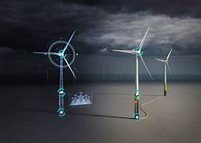

By using digital twin technology, they are now able to create a fully functioning replica of a wind farm and see which wind angles affect the turbine wings the most. By gathering digital data that represents how much energy the wind farm generated during the past 3 months, they are now able to successfully predict how much energy will be generated in the next 3 years by simulating the event in the future using digital twins. By monitoring the wear and tear damage that was caused by windstorms, they are now able to simulate the same amount of damage to 10 wind energy generators and foresee the average lifespan of their wind farm.

### **2.Digital twin is used for aerospace engine monitoring:**

By creating a digital twin of an aircraft’s engine, pilots will have the ability to monitor engine health and progress the simulation 10 hours at a time in order to see if the potential risk of the engine experiencing a fatal failure in the near future. The same concept goes for any other parts of an aircraft.

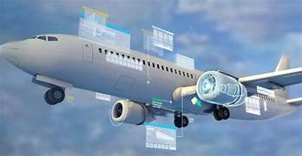

Finally, the answer to how accurate these future simulations will depend on the amount of data that is being gathered, more data means more accurate answers.

### **3.Healthcare industry:**

Healthcare is recognized as an industry being disrupted by the digital twin technology. The concept of digital twin in the healthcare industry was originally proposed and first used in product or equipment prognostics. With a digital twin, lives can be improved in terms of medical health, sports and education by taking a more data-driven approach to healthcare. The availability of technologies makes it possible to build personalized models for patients, continuously adjustable based on tracked health and lifestyle parameters. This can ultimately lead to a virtual patient, with detailed description of the healthy state of an individual patient and not only on previous records. Furthermore, the digital twin enables individual's records to be compared to the population in order to easier find patterns with great detail.

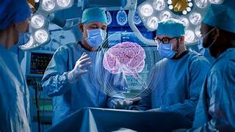

The biggest benefit of the digital twin on the healthcare industry is the fact that healthcare can be tailored to anticipate on the responses of individual patients. Digital twins will not only lead to better resolutions when defining the health of an individual patient but also change the expected image of a healthy patient.

**APPLICATION OF DIGITAL TWIN TECHNOLOGY**

**Power-generation equipment:**

Large engines including jet engines, locomotive engines and power-generation turbines benefit tremendously from the use of digital twins, especially for helping to establish timeframes for regularly needed maintenance.

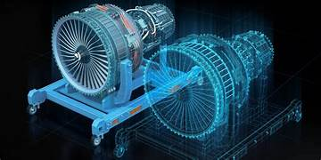

Many businesses are already well accustomed to using digital models for example in manufacturing. CAD (computer-aided design) helps in the development of products, while design reviews allow you to comprehensively and systematically examine designs to ensure they meet all your requirements.

Both applications allow you to test systems, equipment and products long before manufacturing begins. But digital twins come into play when products are being used. They are virtual representations of products or systems and they enable you to run through steps in production and the associated supply chains in digital processes.

Through the IoT we know that the benefit of linking the real to the digital world like this is obvious: customised investigations and tests can be done without too much financial input, resources or manpower.

**Structures and their systems**:

Big physical structures, such as large buildings or offshore drilling platforms, can be improved through digital twins, particularly during their design. Also useful in designing the systems operating within those structures, such as HVAC systems.

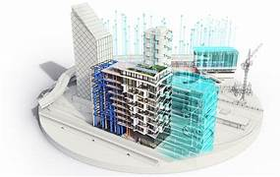

Building owners are asking for digital data at handover, but they must work together with AEC firms to establish when and where the digital twin lifecycle originates. When they agree on what data is needed from the start, desired operational outcomes are achieved.  AEC firms that use a platform like Autodesk Tandem are enabling improved operational efficiencies for the lifetime of the built asset and thus help customers achieve competitive advantage.

**Urban planning:**

Civil engineers and others involved in urban planning activities are aided significantly by the use of digital twins, which can show 3D and 4D spatial data in real time and also incorporate augmented reality systems into built environments.



IES used digital twin technology to create an interactive platform that enables the Trent Basin community to visualise its energy data in real-time. The platform provides information on renewable energy generation and storage, alongside energy consumption data, and general information about the homes.

The aim of the 3D Community Interaction Model was to provide a visual tool that promotes public engagement in the community energy scheme and communicates the results of this low energy housing development. It integrates real-time data of the energy used, generated and stored at the Trent Basin, allows residents to compare household-level data with the community average and see how much energy the project is producing and selling to the grid.

The project makes use of cutting-edge smart home and Internet of Things technologies to better understand and predict energy use and behaviour. This provides residents with information they need to make informed decisions and to help optimise the operation of the community energy scheme.

**Automotive industry:**

Cars represent many types of complexes, co-functioning systems, and digital twins are used extensively in auto design, both to improve vehicle performance and increase the efficiency surrounding their production.

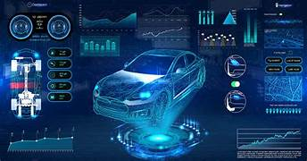

The role of digital twin technology in the automotive industry acts as an intersection between the physical and virtual versions of vehicle prototypes, auto showrooms, and the actual vehicle on the road. The comprehensive digital twin automotive technology has not just changed the dynamics of ordinary vehicles but has also offered a fresh approach to electric vehicles. Digital twin solutions have enabled the design and develop futuristic electric vehicles in the most methodical and cost-efficient manner.

Digital twin technology in the automotive industry has seen long-term success, because of which most of the leading automobile companies have adapted this technology. Hence, there is no doubt that the role of digital twin technology has proven to be a game-changer for the automotive industry.

**CHALLENGES IN DIGITAL TWIN TECHNOLOGY**

It is becoming more evident that Digital Twin runs in parallel with AI and IoT technology resulting in shared challenges. The first step in tackling the challenges is to identify them. Some of the common challenges are found with both data analytics and the Internet of Things, and the end aim is to identify shared challenges for Digital Twins.

**1. IT INFRASTUCTURE:**

The first big challenge is the general IT infrastructure. The rapid growth of AI needs to be met with high-performance infrastructure in the form of up-to-date hardware and software, to help execute the algorithms. The challenge with the infrastructure currently is down to the cost of installing and running these systems. For instance, the costs of the high-performance graphics processing unit (GPUs) that can perform the machine and deep learning algorithms are in the thousands, anything from 1,000to10,000. As well as this, the infrastructure needs updated software and hardware to run such systems successfully.

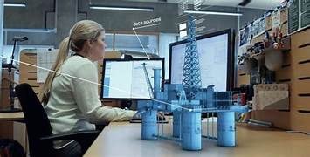

Overcoming this challenge is seen through the use of GPUs “as a service” providing on-demand GPUs at cost through the cloud. Amazon, Google, Microsoft and NVIDIA, to name a few, are offering unique on-demand services similar to traditional cloud-based applications, breaking the barrier to demand, but the poor infrastructure and high cost are still challenging for data analytics. Using the cloud for data analytics and Digital Twins still pose challenges in ensuring that the cloud infrastructure offers robust security.

**2. PRIVACY AND SECURITY:**

Privacy and security is an important topic for anyone concerned with the computing industry and this is no different when performing data analytics. Laws and regulation are yet to be established fully because of the infancy of AI. The challenge is more scrutiny, regulation and measures concerning AI in the future as the technology grows. Future regulation ensures the development of algorithms that take steps to protect user data. The General Data Protection Regulation (GDPR) is a new regulation that ensures the privacy and security of personal data across the UK and throughout Europe.

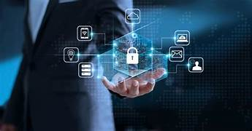

Regulation is one step to ensure personal data is protected, while another method is federated learning, a decentralised framework for training models. It allows users’ data in a learning model to stay localised without any data sharing, addressing privacy and security issues when implementing data analytics within a Digital Twin.

**3. CONNECTIVITY:**

Despite this growth in IoT use, the challenges of connectivity still exist. These are especially prevalent when trying to achieve the goal of real-time monitoring. A large number of sensors within one manufacturing process poses a significant challenge when trying to connect all of them simultaneously.

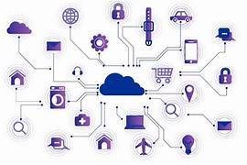

Challenges with attributes like power outages, software errors or ongoing deployment errors are impacting this overall goal of connectivity. Just having one sensor not fully connected could dramatically affect the overall goal of a given process. For example, IoT devices are one source of feeding data to AI algorithms; this can become a major challenge as all the data is required for it to perform accurately and missing IoT data could detrimentally affect the running of the system. Retrofitting machines and harvesting the data already served up by the machine is a method of ensuring all data is collected. Imputation methods are a process of finding replacement values for missing IoT sensor data, a concept used to ensure full connectivity and facilitate the running of AI models with high accuracy and little to no missing data.

**4. TRUST:**

Trust is another challenge that concerns much of the field of AI. Firstly, being because it is relatively new and secondly because unless the developer is familiar with the complexity, the use of AI can be daunting. The anxiety that robots and AI will become a dominant force on earth, taking control of key infrastructure from humans is a barrier to trust.

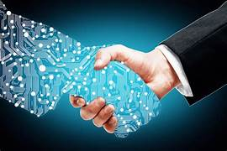

The issue of trust can be a barrier because the portrayal of the AI mostly focuses on the negative effects that could occur. Positive media stories in the field of artificial intelligence are becoming more common, but the challenge is evident, and the need for wider exposure of AI and the positive uses would help overcome challenges with trust. Privacy and security challenges contribute to these trust issues, but more comprehensive privacy and security regulation in AI builds trust.

**ADVANTAGES OF DIGITAL TWIN TECHNOLOGY**

* Increased reliability of equipment and production lines.
* Improved OEE through reduced downtime and improved performance.
* Improved productivity.
* Reduced risk in various areas including product availability, marketplace reputation, and more.
* Lower maintenance costs by predicting maintenance issues before breakdowns occur.
* Faster production times.
* New business opportunities such as mass customization, mixed manufacturing, small-batch manufacturing, and more.
* Improved customer service as customers can remotely configuring customized products.
* Improved product quality, and enhanced insight into the performance of your products, in multiple real-time applications and environments.
* More efficient supply and delivery chains.



**DISADVANTAGES OF DIGITAL TWIN TECNOLOGY**

* The success of technology is dependent on internet connectivity.
* The security is at stake.
* The digital twin’s concept is based on 3D CAD models and not on 2D drawings.
* Digital twin will be required across entire supply chains.
* The challenges involved here include globalization and new manufacturing techniques. Managing all these design data for digital twin among partners and suppliers as the physical product evolves will be a challenge.

**FUTURE SCOPE OF DIGITAL TWIN TECHNOLOGY**

A fundamental change to existing operating models is clearly happening. A digital reinvention is occurring in asset-intensive industries that is changing operating models in a disruptive way, requiring an integrated physical plus digital view of assets, equipment, facilities and processes. Digital twins are a vital part of that realignment.

The future of digital twins is nearly limitless, due to the fact that increasing amounts of cognitive power are constantly being devoted to their use. So digital twins are constantly learning new skills and capabilities, which means they can continue to generate the insights needed to make products better and processes more efficient.

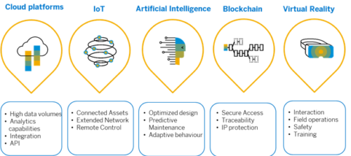

Digital Twin adoption and market size will continue to increase exponentially, adoption of digital twins across products, machines and processes continues to skyrocket across enterprises. Industry analysts and consultants agree Deloitte Forecasts, the global market for digital twin technologies will reach $16 billion by 2023.

**CONCLUSION**

The growth in Digital Twin use has seen a shift in recent years, facilitated by an increase in the number of published papers and industry leaders investing heavily in developing Digital Twin technology. It would not be possible without the same growth in the AI, IoT and I-IoT fields, which are becoming key enablers for Digital Twins.

The majority of the Digital Twin research is focused on the manufacturing field, as evidenced through the large proportion of papers in this area reviewed above. The number of papers found in manufacturing is noticeably higher compared to papers discussing Digital Twins for smart cities and healthcare, highlighting gaps in the research for these areas.

The review carried out above highlights two other areas of growing interest, Digital Twins for healthcare and smart cities. Thus, the reason why the paper contributes to a categorical review that includes not only manufacturing but healthcare and smart cities. The paper discusses each area, highlighting how researchers are developing Digital Twins, while also identifying challenges and key enabling technologies, thus aiding future work.

**REFERENCES**

1. Digital Twin: Enabling Technologies, Challenges and Open Research by Aidan Fuller and Charles Day.
2. <https://www.toobler.com/>
3. A Survey on Digital Twins: Architecture, Enabling Technologies, Security and Privacy and Future Prospects, By Zhou Su and Yi liang Liu.